**How to play Splinterland**

**1. Game introduction**

**Basic information**

Splinterlands (formerly Steemmonsters) is a turn-based card battle game based on the Hive blockchain platform. Like Axie Infinity, it is an old blockchain game that has been out for several years. Throughout its development, it has used NFTs and land auctions, and other related elements. At present, the daily activity of the game can be seen on DappRadar, where it is often in the top three positions. The game’s governance token SPS was launched on July 26 this year. This game is similar to the classic game "Hearthstone". Players must collect cards and combine different decks to compete with other players. After winning a game, they can get cards and Dark Energy Crystals (DEC). Cards can be used for battling, leveling up, selling or renting to other players, and rare cards have greater collection value.

Splinterlands official website:

https://splinterlands.com

Splinterlands Twitter:

https://twitter.com/splinterlands

Discord Official Community:

https://discord.com/invite/CAFJRjY

Telegram Official Community:

https://t.me/splinterlandsHQ

**2. Game tokens:** Fuel token: DEC; governance token: SPS.

* Game Token DEC 1DEC=0.003HIVE

DEC is mainly used for in-game purchases of various card packs, land, items, personal rankings, etc.

There are two ways to get it:

▲By completing various tasks and official events in the game, such as battle rankings. Players can earn DEC rewards after winning games.

▲Out-of-game purchases: TRX can be used to purchase things on the trading platform.

Buy more cards with DEC. To improve the player's winning rate, get more battle rewards and rare cards. Rare cards can be traded for a profit on the NFT trading market.

* Governance Token SPS Currently 1SPS=0.2248U

SPS is an ERC-20 token issued on BSC, with a total circulation of 3 billion.

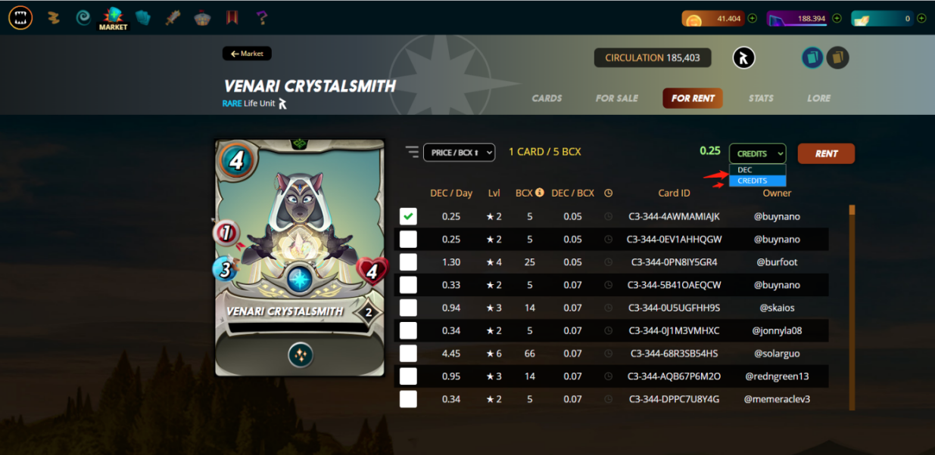

**3. Game Features:**

* Amazing Design

The game graphics are very well-made, the special effects soundtrack is cool, and the gameplay is innovative and diverse. It can be regarded as a chain game boutique. In addition to the NFTization of various cards, Splinterlands has also added elements such as land auctions, NFT card transactions, and card synthesis to increase the liquidity of cards and land, solving the problem that most digital card games have where players are unable to trade or sell game assets to other players.

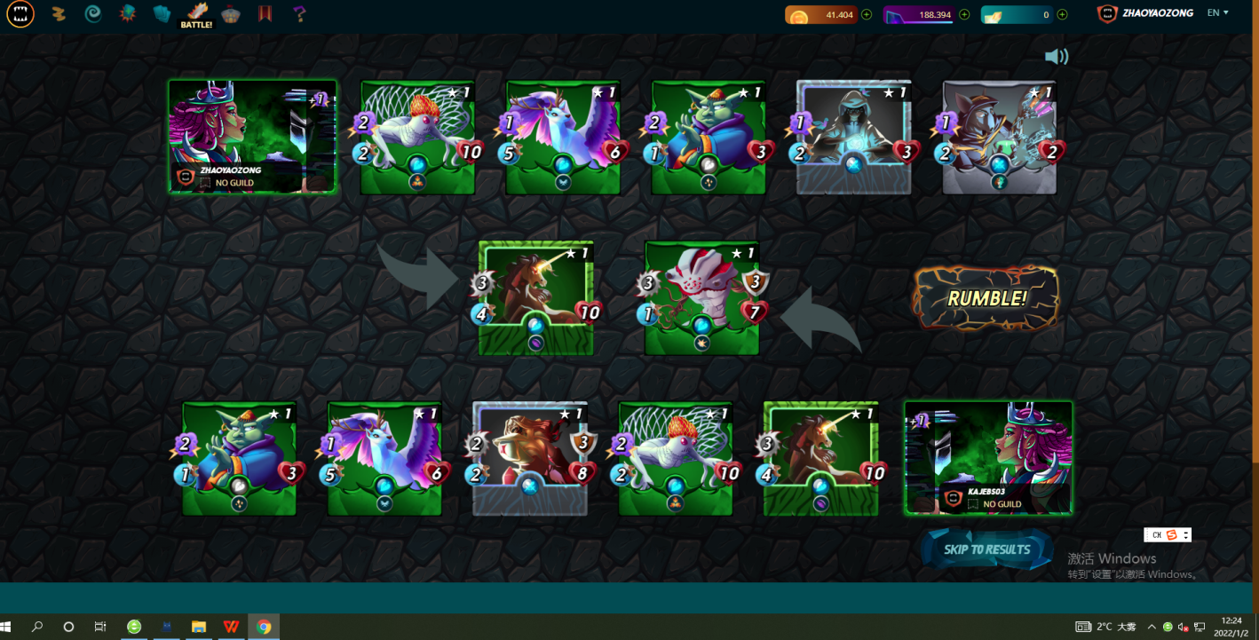

* Play to Earn Mode

Players can make money while playing the game, and can quickly participate for only $10, which is a lower threshold compared to similar games. Players have a variety of methods to earn money:

* Complete daily tasks and earn season rewards
* Play games to earn crystal DEC
* Increase the percentage of airdrop points and get daily SPS airdrops
* Card trading, land trading, and land leasing can all earn money

There are even more ways to make money, but players will need to enter the game and explore it more slowly.

* Increase growth potential

The great imagination of Splinterlands lies in the land-based Metaverse, which allows players to create guilds, build castles, and create a wider Metaverse space.

* Airdrop plan

On July 27, 2021, the Splinterlands team will start the first airdrop of SPS tokens to all players, with a total of approximately 400 million airdrops, lasting up to 1 year. Everyone who holds DEC tokens, card NFTs and/or land NFTs will receive SPS airdrops. The proportion of airdrops that each player receives will be determined according to the weight of in-game assets on the blockchain, further improving the game's economic model and incentives mechanism.

**2. Preparations Before Playing**

**1. Game Login**

(1) Players can login to the official website to start playing the game on a PC (https://splinterlands.com/), or alternatively they can download the app. For the first time, it is recommended to play on a PC. The app is all in English, and the PC version can be translated into Chinese. Select Little Fox Wallet and click to enter, then input an email address to register an account and confirm registration.

(2) After logging in to the game, Splinterlands lends players a set of starter cards that can be used in battle, allowing players to learn basic card knowledge. If players want their own collection of playable NFT cards, they will have to pay $10 for the Summoner's Spellbook (must buy).

(3) After logging in to an account, there is a tutorial, whereby the system guides players step by step on how to operate the game. All instructions are in Chinese, and a plot is included, which can be clicked to directly watch. After the final scene, players can click to start the game.

Start a random match against opponents.

In the end, the player wins. (Start the official game tour)

**2. Cards are Divided into Six Races**

In order to score easily, players must first understand the attributes and functions of the cards.

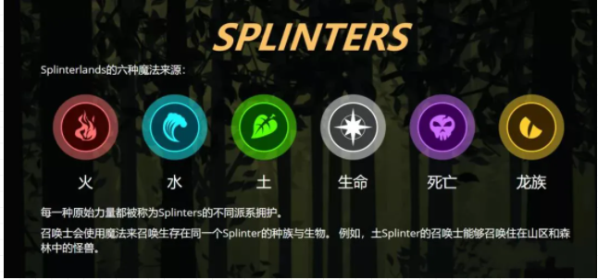

Summoner Cards and Monster Cards. For each battle, players must first select a Summoner Card of one of the races. The Summoner will summon monsters of the same race. The card configuration also needs to be fire, but there are some special cases here. For, example, dragon type summoners can match monster cards of any other type.

Then, there is a class of monster cards that are generic (neutral), which can be matched with any summoner.

Each card has different numbers displayed on it:

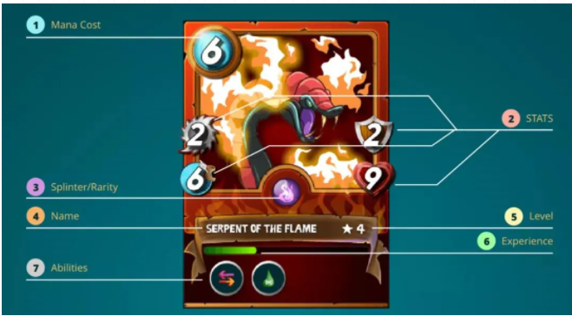

Here we will explain each one according to the English annotations above:

( 1 ) Mana Cost, which is mentioned in the basic article. Each game will give a total mana value, and the sum of the mana value of the players’ cards is required to be less than or equal to the total mana value. The other card's mana value is equal to or less than that. The higher the magic value, the stronger the overall strength.

( 2 ) Stat Attributes. There are 4 kinds of stats (ATK, DEF, SPD, HP)

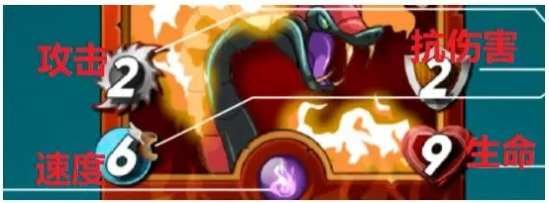

ATK (there are 3 types of attack - melee attacks, long-range attacks, and magic attacks). The higher the number, the stronger it is. If it is not jagged and is instead a bubble, then it is a magic attack. The heart displayed at the bottom right is the HP. It is possible to be hit once by the opponent, decreasing HP by 1-2. The monster will die if it goes down to zero. The first player to lose all of HP for all of their cards loses. The DEF value above can protect HP from being lost at certain times, but it doesn’t work for magic attacks.

(3) Rarity corresponds to 3.

(4) 456 corresponds to the name level experience.

(5) 7 - Super power, which is only available for some cards. There are many kinds of abilities, such as those that can restore HP for oneself or allies, and those that can increase or decrease damage, etc.

Generally speaking, in terms of lineup, try selecting powerful cards without exceeding the mana value, such as those with high HP and strong ATK. The order in which the cards are placed will also affect the outcome of the game. Generally speaking, place tanks with high HP or DEF at the top and bottom where the lineup is most vulnerable.

In addition, there are some rules of mutual restraint between certain attributes. Before battle, players can look at their opponent's historical records, and choose a comparatively strong lineup to deal with them. Novices can explore on their own.

**3. Gameplay**

1. Click Battle to enter the card selection page. First, players will need to select a summoner card (if they want to complete a task, they can choose cards with the same color as the task), and then start matching monster cards. Up to 6 cards can be chosen.

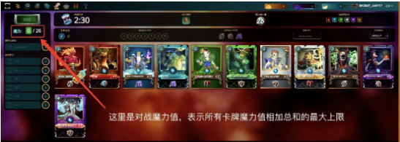

2. The card combination needs to be determined according to the magic value of the battle. As shown in the above figure, the magic value is 26, which refers to the sum of the magic value of all cards (the value in the upper-left corner of each card) must be less than or equal to 26 to start a battle. This means that players must match cards with the best attributes within the magic value range. Players have three minutes to select their cards, and must click Play to start the battle.

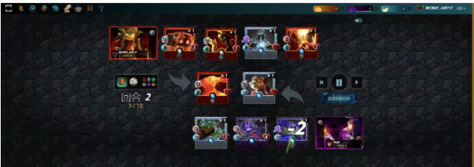

**3. Location Placement Strategy**:

The first round of monsters must be tank-type monsters in order to resist the first round of violent attacks. Shield skill: This can effectively weaken the enemy’s melee physical attacks and long-range sniping attacks (suitable for the first position in the first round of battle).

For monsters in the second position, try selecting a monster with the Reach skill. These can skip the first position and attack the enemy monster directly in the second position, which is a very practical skill.

The monsters in the third position are special, and usually attack with magic or close-range physical attacks and sneak skills.

In addition to melee physical attacks, magic attacks are also indispensable in the fourth position. Magic attacks are 100% guaranteed to hit, with absolutely no mistakes.

The remaining mana (magic value) can be used to select long-range snipers. Before the two sides start battling, they will add their summoner's buffs and skills to their monsters.

For card battles, if the speed is the same, then monsters attack in this order: magic > long-range > melee. For cards with the same nature, the attack order is random.

At present, the combination with the highest win rate is: grass-type summoners with rebound skills and grass-type monsters, or water-type summoners with +1 water-type magic. For water-type magic monsters, the battlefield can be quickly cleared to win the game.

**4. Game Modes**

•Daily tasks

DEC is the main token in Splinterlands, and can be earned by winning ranked matches;

DEC is an in-game utility resource that can be used to purchase new cards or upgrade existing ones;

According to the requirements every day (usually lets players use a specific attribute card to play), players will have a chance to open one treasure chest if they win five games. Treasure chests contain random DECs or cards. Before, players could buy potions and then open multiple treasure chests at once. However, now this results in negative income, and is not very recommended.

Currently, bronze players can only open one treasure chest per day. The higher a player’s rank, the more things that can be opened when tasks are completed. According to the official expected value of a single gain, 65-75DEC can be received.

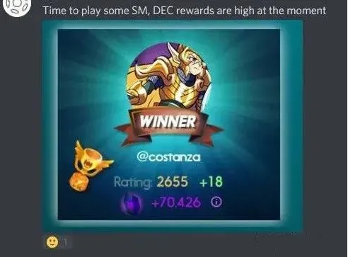

**5. Land Introduction**

Splinterlands in-game land is currently sold out.

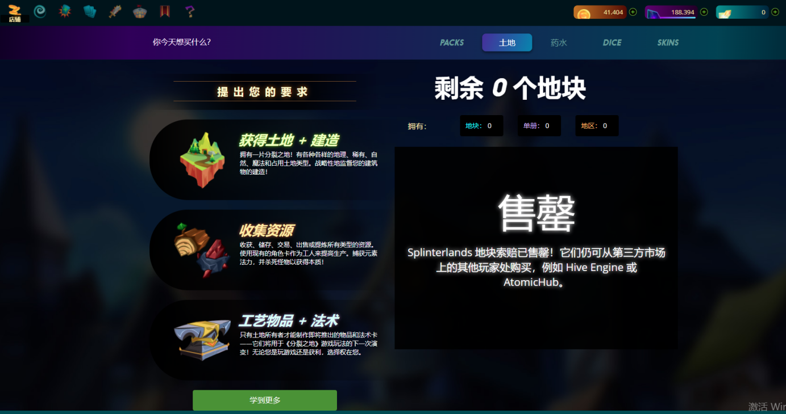

4 grades of land :

* Ordinary
* Rare (fertile plains)
* Epic (rich swamps)
* Legendary (overflowing jungle)

The rarity of land can determine the abundance of natural or magical resources it has, or how many monsters are on an occupied tile. A part of the tile name indicates its modifier.

Normal rare tiles do not have any modifiers in front of the terrain type. A tile that is both an overflow (legendary) and a magic or occupation type tile can be thought of as a gold leaf legendary monster or summoner card.

14 types of land terrain:

Plains, hills, tundra, wetlands, swamps, mountains, canyons, craters, rivers, lakes, forests, jungles, deserts, and wastelands.

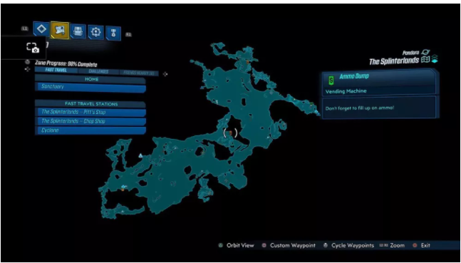

**Three categories of land:**

* Nature

One of the four natural resources (grain, wood, stone, and ore) that can be farmed or harvested from land. These are required to build, upgrade, and maintain all the various structures that can be built.

* Magic

Enriched with one of six magical resources, each is associated with a type of split magic - Virtulium (Life), Reclaimed Soul (Death), Urana Seed (Earth), Spark Stone (Fire), Bottled Storm (Water), and sunstone (Dragon). Magic resources are much rarer than natural resources, and are one of the two components needed to forge items and spell cards.

* Occupied

These are inhabited by wild monsters. Players can fight these monsters and obtain their essence, which is the second necessary material for casting items and magic cards, in addition to magic resources.

There can only be one building on a piece of land at any one time. The different types of buildings are: warehouse, item and spell manufacturing hubs. These have no no restrictions on what land they can be built on. Meanwhile, other types of buildings, such as resource gathering buildings, can only be built on land that possesses certain types of resources.

* Natural resource harvesting
* Natural resource extraction
* Natural resource storage
* Magic resource harvesting
* Magic resource storage
* Essence collecting
* Item and spell crafting

There are two special types of buildings - the Castle and the Keep - which are pre-existing buildings found on certain tiles, and cannot be destroyed or removed in any way. These buildings offer special benefits to their owners and the surrounding areas.

**6. Championship**

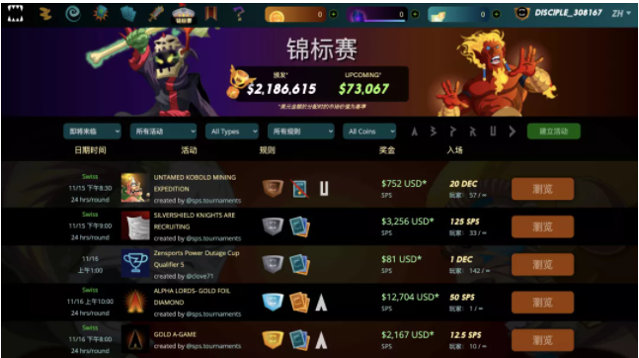

There are tournament matches every day, and registration is required. The fee is 2U. The registration fees of all players is put into a prize pool, which is then automatically allocated to the winners after the competition ends. Different prizes can be obtained according to the final results. Many tournaments have card and level restrictions, such as not allowing the use of legendary cards, etc. Generally, the rewards won by the top players is about ten times the registration fee.

Player levels also have 6 tiers:

Each tier has 3 levels. Lots of victories are required to improve the level, and the treasure chests obtained cannot be opened until the end of the season (bronze and silver have a 25% drop rate).

* Rookie
* Bronze
* Silver
* Gold
* Diamond
* Champion

* Beginners must reach Bronze 2 to win $DEC rewards

1. **How to Earn Money**

(1) The daily tasks and qualifying matches mentioned above;

(2) Selling NFTs;

Cards in Splinterlands are NFTs, which makes each card unique and tradable on the market;

A card earns experience and can be leveled up by consuming duplicate cards;

The higher the level of a card, the better the statistics it obtains;

When maxed out, cards can even gain special abilities.

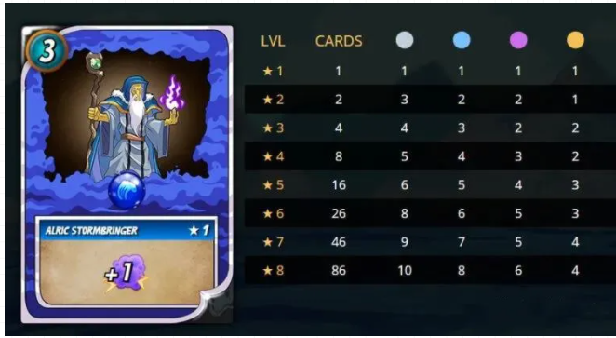

Cards can be obtained by completing daily quests through loot rewards (boxes). If you are lucky, you can get find highly rare cards;

The higher the stats and rarity of a card, the more valuable it will be when sold on the market.

(3) Renting NFTs

If players accumulate a lot of cards, they can rent them out to earn passive income while still maintaining ownership of the cards.

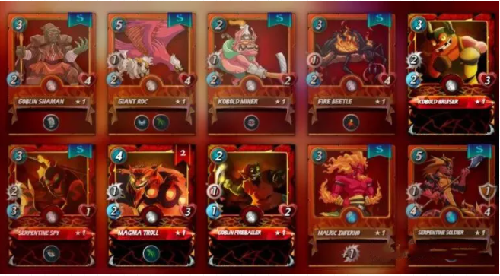

When renting out a card, the lessee pays the full value of a contract, depositing their money into a fund. The "lesser" will then earn DEC tokens every day;

Leasing rare and high-tier cards gives new players who can’t afford certain cards a chance to compete with veterans and move up the league ranks or enter tournaments;

(4) Earn SPS

Splinterlands will launch the governance token SPS in early August 2021, along with a staking platform.

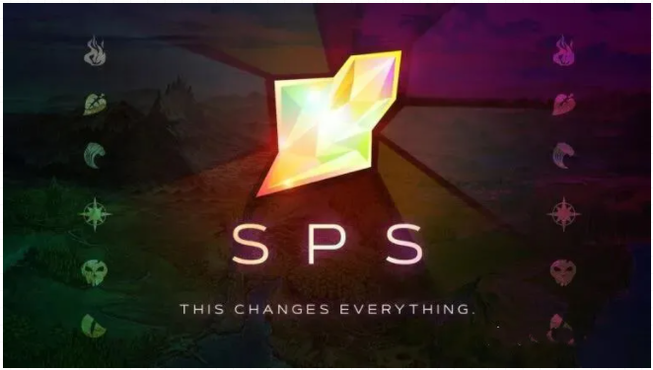

Players holding SPS can participate in the governance voting system, giving them a degree of control and ownership over the direction of the game and its ecosystem;

**Staking** SPS;

For the next few months, all players who own DEC tokens, cards, or land NFTs in Splinterlands will receive SPS tokens every day;

Players will receive a portion of the 7.5 million monthly SPS rewards starting within a week of the SPS token launch. This bonus amount will be reduced by 1% per month.

(5) Land

There is a saying among foreign players: GameFi without land is not real GameFi.

Land division is indispensable to land, otherwise it would be a castrated version of GameFi.

Praetoria is the world of Splinterlands, which is divided into 150,000 separate parcels;

The main purpose of owning land in Splinterlands is to forge new items and spell cards;

Landowners can build buildings that can harvest, refine, or manufacture resources and items.

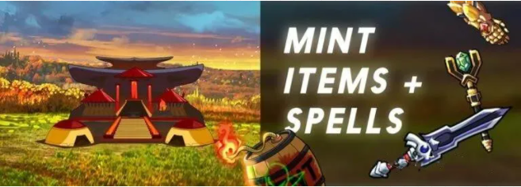

Each piece of land in Splinterlands is unique because of its type, category, and rarity.

However, all plots are sold out right now, and the only way to get land now is to buy it from other players.